**CRIME MANAGEMENT SYSTEM**

**DATABASE CREATION**

create database CrimeManagementSystem;

use CrimeManagementSystem;

**TABLE CREATION**

CREATE TABLE Crime (

CrimeID INT PRIMARY KEY,

IncidentType VARCHAR(255),

IncidentDate DATE,

Location VARCHAR(255),

Description TEXT,

Status VARCHAR(20)

);

CREATE TABLE Victim (

VictimID INT PRIMARY KEY,

CrimeID INT,

Name VARCHAR(255),

ContactInfo VARCHAR(255),

Injuries VARCHAR(255),

FOREIGN KEY (CrimeID) REFERENCES Crime(CrimeID)

);

CREATE TABLE Suspect (

SuspectID INT PRIMARY KEY,

CrimeID INT,

Name VARCHAR(255),

Description TEXT,

CriminalHistory TEXT,

FOREIGN KEY (CrimeID) REFERENCES Crime(CrimeID)

);

**VALUES INSERT**

INSERT INTO Crime (CrimeID, IncidentType, IncidentDate, Location, Description, Status)

VALUES

(1, 'Robbery', '2023-09-15', '123 Main St, Cityville', 'Armed robbery at a convenience store', 'Open'),

(2, 'Homicide', '2023-09-20', '456 Elm St, Townsville', 'Investigation into a murder case', 'Under Investigation'),

(3, 'Theft', '2023-09-10', '789 Oak St, Villagetown', 'Shoplifting incident at a mall', 'Closed');

INSERT INTO Victim (VictimID, CrimeID, Name, ContactInfo, Injuries)

VALUES

(1, 1, 'John Doe', 'johndoe@example.com', 'Minor injuries'),

(2, 2, 'Jane Smith', 'janesmith@example.com', 'Deceased'),

(3, 3, 'Alice Johnson', 'alicejohnson@example.com', 'None');

INSERT INTO Suspect (SuspectID, CrimeID, Name, Description, CriminalHistory)

VALUES

(1, 1, 'Robber 1', 'Armed and masked robber', 'Previous robbery convictions'),

(2, 2, 'Unknown', 'Investigation ongoing', NULL),

(3, 3, 'Suspect 1', 'Shoplifting suspect', 'Prior shoplifting arrests');

**1.select * from Crime where Status ='open';**

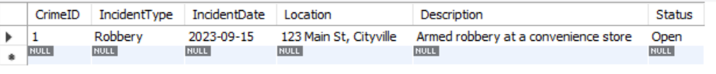

**2.** **select count(incidenttype) from crime;**



**3.** **select distinct incidenttype from crime;**

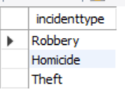

**4.** **select * from crime where incidentdate between '2023-09-01' and '2023-09-10';**

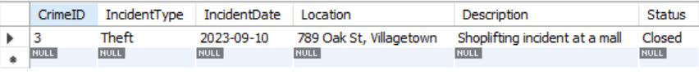

**5** **– I DON’T HAVE AGE IN VICTIM AND SUSPECT SO I ADD AGE**

**select name, age**

**from victim**

**union**

**select name, age**

**from suspect**

**order by age desc;**

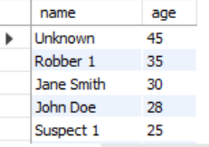

**7.** **select incidenttype, count(incidenttype)**

**from crime**

**where status = 'Open'**

**group by incidenttype;**



**8.** **select name**

**from victim**

**where name like '%Doe%'**

**union**

**select name**

**from suspect**

**where name like '%Doe%';**

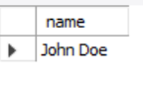

**9.** **select name**

**from victim v**

**join crime c on v.crimeid = c.crimeid**

**where c.status in ('Open', 'Closed')**

**union all**

**select name**

**from suspect s**

**join crime c on s.crimeid = c.crimeid**

**where c.status in ('Open', 'Closed');**

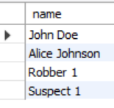

**10.** **select distinct c.incidenttype**

**from crime c**

**join victim v on c.crimeid = v.crimeid**

**where v.age in (30, 35)**

**union**

**select distinct c.incidenttype**

**from crime c**

**join suspect s on c.crimeid = s.crimeid**

**where s.age in (30, 35);**

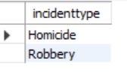

**11.** **select v.name**

**from victim v**

**join crime c on v.crimeid = c.crimeid**

**where c.incidenttype = 'Robbery'**

**union**

**select s.name**

**from suspect s**

**join crime c on s.crimeid = c.crimeid**

**where c.incidenttype = 'Robbery';**

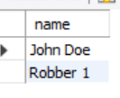

**12.** **select incidenttype**

**from crime**

**where status = 'Open'**

**group by incidenttype**

**having count(*) > 1;**



**13.** **select c.crimeid, c.incidenttype, c.status, s.name as suspectname, v.name as victimname**

**from crime c**

**join suspect s on c.crimeid = s.crimeid**

**join victim v on s.name = v.name**

**where c.crimeid != v.crimeid;**



**14.** **select c.crimeid, c.incidenttype,**

**v.name,v.contactinfo, v.injuries,**

**s.name,s.description,s.criminalhistory**

**from crime c**

**left join victim v on c.crimeid = v.crimeid**

**left join suspect s on c.crimeid = s.crimeid;**

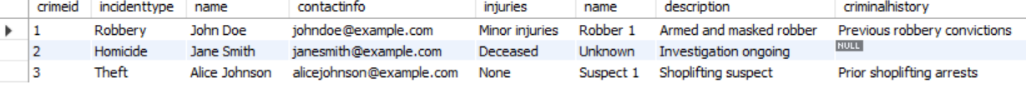

**15.** **select c.crimeid, c.incidenttype, c.status,**

**s.name, s.age, v.name, v.age**

**from crime c**

**join suspect s on c.crimeid = s.crimeid**

**join victim v on c.crimeid = v.crimeid**

**where s.age > v.age;**

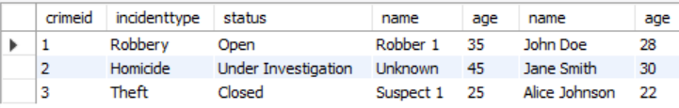

**16.** **select s.suspectid, s.name**

**from suspect s**

**join crime c on s.crimeid = c.crimeid**

**group by s.suspectid, s.name**

**having count(c.crimeid) > 1;**



**17.** **select c.crimeid, c.incidenttype, c.status**

**from crime c**

**left join suspect s on c.crimeid = s.crimeid**

**where s.suspectid is null;**



**18.** **select c.crimeid**

**from crime c**

**group by c.crimeid**

**having count(distinct c.incidenttype) = 2**

**and sum(c.incidenttype = 'Homicide') > 0**

**and sum(c.incidenttype = 'Robbery') > 0;**

**19.** **select c.crimeid, c.incidenttype, c.status, s.name**

**from crime c**

**left join suspect s on c.crimeid = s.crimeid;**

**20.** **select s.suspectid, s.name**

**from suspect s**

**join crime c on s.crimeid = c.crimeid**

**where c.incidenttype in ('Robbery', 'Assault');**